B & D Tree Farm Directions

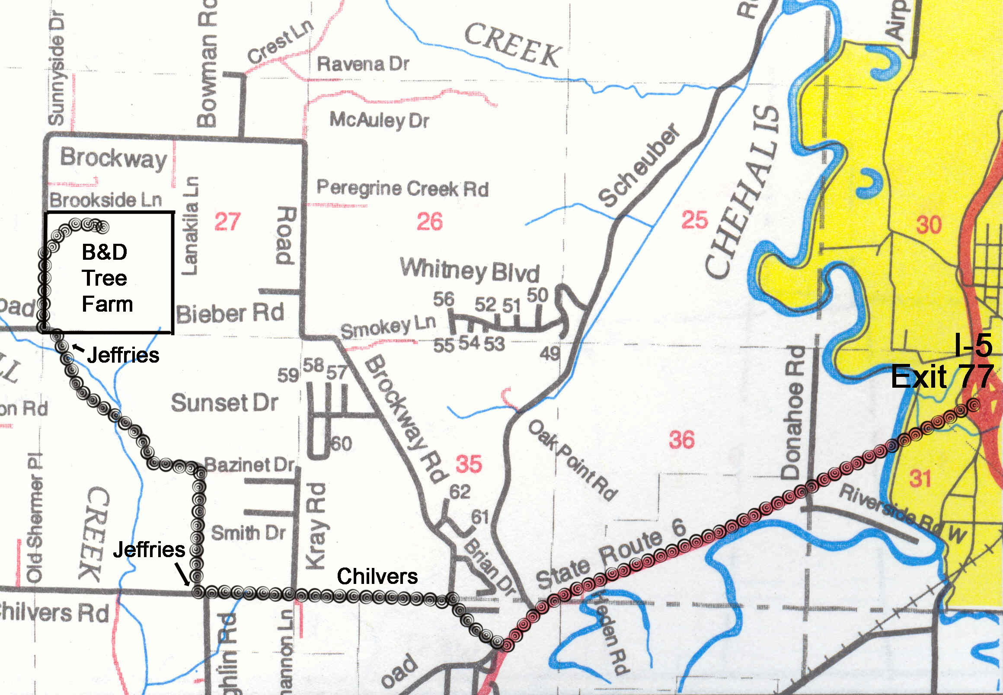

Directions
- Take I-5 Exit #77 (west to PeEll & Ocean Beaches exit)
- Travel west 2 miles on Hwy #6
- Turn right at Chilvers Road (under a large church on your right & just beyond Scheuber road.
- Go up the hill 0.3 mile (go past Stearns Rd on left & Riverview Dr. on right)
- Stay left on Chilvers Road at junction (Brockway begins as road going straight ahead at jct.)
- Continue 1 mile to Jeffries Road
- Turn right on Jeffries Road
- Continue 1.4 miles to jct. with Brockway Road
- Turn right on Brockway and go slightly less than ½ mile up the hill
- Turn right at Tree Farm entrance (red gate and Cedar log with chain saw letters “B & D Tree Farm”)

